The Cape sea urchin *Parechinus angulosus,* a potential new market product for South African aquaculture?

********

Aimee Cloete

Supervisor (s):

Prof John J. Bolton (Emeritus Professor UCT)

Dr Marissa Brink-Hull (UCT Postdoctoral Research Fellow)

Dr Brett M. Macey (DFFE, Hon. Research Associate UCT)

Minor Dissertation submitted in partial fulfilment of the requirements for the degree of Master of Science in Applied Ocean Science

Department of Biological Sciences

University of Cape Town

Rondebosch, Cape Town

South Africa 7701

# **Declaration**

I declare that this project is my own, unaided work and has not been previously submitted, in whole or in part, for the award of any degree. Where use has been made of the research of others, it has been duly acknowledged in the text. This project is carried out in the Department of Biological Sciences under the supervision of Dr Marissa Brink-Hull, Dr Brett Macey and Professor John Bolton.

________________________

Aimee Cloete

Department of Biological Sciences, University of Cape Town

# **Acknowledgements**

I would like to acknowledge the All Atlantic Ocean Sustainable, Profitable and Resilient Aquaculture (ASTRAL) project, Dr Marissa Brink-Hull, Dr Brett Macey and Professor John Bolton for the provision of samples, use of facilities and supervision of the project. This project has received funding from the European Union’s Horizon 2020 research and innovation programme under grant agreement No 863034. Dr Brett Macey has ensured that this project has been approved by the Aquaculture Animal Ethics Committee (AAEC) in Fisheries Branch of the Department of Environment, Forestry and Fisheries (DEFF) under project approval No 20210224_su_03_Macey.

(acknowledgement of family, friends etc who have assisted..)

# **Abstract**

(will start on this after discussion is complete)

# **Contents**

**Declaration** 1

**Acknowledgements** 2

**Abstract** 3

**Contents** 4

**List of figures and tables** 6

**List of acronyms** 7

**1.** **Introduction** 8

1.1. Global aquaculture 8

1.2. African and South African aquaculture 9

1.1. Research aim and objectives 11

**2.** **Literature review** 12

**3.** **Materials and methods** 13

3.1. Ethics statement 13

3.2. Sea urchin collection 13

3.3. Experimental setup 13

3.4. Data collection 15

*3.4.1.* *Somatic growth and feed conversion ratio* 15

*3.4.2.* *Gonad quality and development* 15

3.5. Statistical Analyses 16

**4.** **Results** 17

**5.** **Discussion** 20

**6.** **Conclusion** 21

**7.** **References** 21

**8.** **Appendix** 23

8.1. Actual Values 23

8.2. Somatic growth rate values 36

8.2.1. Somatic growth rate statistical models 42

# **List of figures and tables**

(to be completed as tables and figures are added – format to be reviewed)

Figure 1: World capture fisheries and aquaculture production (FAO,2022)

Figure 2: Image of juvenile abalone (Haliotis midae) sheltering beneath Cape sea urchins (Parechinus angulosus) in Simon’s Town, Cape Town, South Africa (Peter Southwood, 2005).

Table 1. Tank treatment allocation (F: formulated feed, M: mixed diet, U: ulva, K: kelp). Shaded tanks receive heated water, unshaded tanks receive water at ambient temperature.

# **List of acronyms**

ASTRAL All Atlantic Ocean Sustainable, Profitable and Resilient Aquaculture

AAEC Aquaculture Animal Ethics Committee

DEFF Department of Environment, Forestry and Fisheries

DOM

IMTA Integrated Multi-Trophic Aquaculture

ISA

GSI Gonadal Somatic Index

POM

SGR Specific Growth Rate

# **Introduction**

## Global aquaculture

Aquatic foods play a crucial role in ensuring food and nutrition security, particularly for vulnerable coastal populations, by providing accessible and affordable sources of proteins and micronutrients (FAO, 2022). The increasing demand for fish products, coupled with the diminishing productivity of wild-caught marine fish stocks, mostly due to the overexploitation of fish stock, positions the aquaculture industry as a significant contributor to the global fish supply (Granada et al. 2016) (Figure 1). The contribution of aquaculture to the global production of aquatic animals reached a record 49.2 percent in 2020, but despite the great diversity in farmed aquatic species, only a small number of “staple” species dominate aquaculture production (FAO, 2022). Further development of the aquaculture industry is necessary to meet growing demand for fish products.

Aquaculture of fed aquatic animals continues to outpace that of non-fed aquatic animals making the aquaculture industry an important consumer of wild-caught marine fish stocks by using fishmeal in aquafeeds, raising concerns about the sustainability of the industry. Aquaculture effluent is another growing concern for the rapidly expanding industry. Both fresh- and saline water aquaculture require large amounts of water with good quality. Uneaten feed and waste products, result in the accumulation of suspended solids, otherwise known as particulate organic matter (POM) and dissolved organic substances (DOM), which contain compounds such as nitrogen and phosphorus, and possibly also other chemicals that are used to prevent diseases of aquatic species (Jegatheesan et al., 2011). This effluent water is discharged into the environment, which if untreated can be detrimental to the surrounding environmental and human health. Thus, intensive development of aquaculture has raised a range of environmental concerns such as effluent discharge, excessive use of resources and dependence on commercial feed (Granada et al., 2016) placing a spotlight on the need for research on sustainable aquaculture systems and practices.

Figure 1: World capture fisheries and aquaculture production excluding aquatic mammals, crocodiles, alligators, caimans, and algae. Data expressed in live weight equivalent. (FAO,2022)

## African and South African aquaculture

Africa’s contribution to global aquaculture production in 2020 was 1.92%, with Egypt being the main producer for the continent (FAO, 2022). This figure is small when one considers the size of the continent and crucial role aquatic foods play in contributing to the overall intake of animal proteins in numerous African countries. With the anticipated increase in population growth for the African continent and declines in fisheries projections, the slow growth of aquaculture production poses a significant risk to food security considering the widespread undernourishment in the region. The untapped potential of the region’s extensive inland waterways and coastlines, coupled with a growing deficit in fish supply, presents a significant opportunity for African aquaculture to meet the rising demand for aquatic foods from a growing and rapidly urbanizing consumer population (Britz & Venter, 2016).

South Africa is endowed with good infrastructure, business institutions, and supply chains, however, the potential for aquaculture production is limited by the high energy coastline combined with water scarcity in inland areas thus, South Africa has focused on the development of shore-based marine aquaculture (Britz & Venter, 2016). The powerhouse of South African aquaculture is abalone which is produced primarily for export to Asia and outshines all other South African aquaculture products in terms of product value, employment and production volume with a 76% share of the overall value generated by the aquaculture sector (Britz & Venter, 2016).

## Diversification of the local aquaculture industry

Why is diversification important?

IMTA: Integrated multi-trophic aquaculture (IMTA) is an advanced form of aquaculture considered a suitable approach to limit aquaculture nutrients and organic matter outputs through biomitigation (Granada et al., 2016). In IMTA systems, nutrients from uneaten feed and excreted waste from fed species become food for extractive species (FAO, 2022). Converting the waste products from one species into a valuable resource for another reduces the amount of nutrients released into the environment while enhancing overall productivity. The extractive species in IMTA systems are both traded as a commodity and used as a biofiltration system, which increases their value to the farm, this is especially important for extractive species with low commercial value or species which are new entrants to the market. The implementation of IMTA systems can increase the efficiency of aquaculture systems and contribute to the development of a sustainable aquaculture industry, particularly when species that are ecologically compatible are co-cultured (Kang et al. 2003; Kim et al. 2015). IMTA has the potential to reduce environmental impacts, increase profitability and diversify commercial production in a sustainable way.

IMTA in SA abalone industry: ***

SA Tripneustes research (what is the urchin product exactly, how does it compare?)

Tripneutes/Ulva potential

WW urchins work but most of SA coast is cold

Parechinus & Parechinus/abalone potential

The high value abalone species, *Haliotis midae* and the Cape sea urchin, *Parechinus angulosus,* have a similar preferred temperature range (12 – 20 °C) (Fricke 1980; Britz et al. 1997; Day and Branch 2002a) and commonly occur together in nature, particularly during the juvenile stages of the abalone life cycle (Day and Branch 2000, 2002a).

Laboratory experiments by Day & Branch (2002a) showed that juvenile abalone prefer to shelter beneath urchins rather than under rocks and crevices. One of the reasons for this preference is that there is insufficient microalgae growth under rocks and crevices to meet the dietary requirements of juvenile abalone (Day & Branch, 2002a) and therefore, the juvenile abalone need to leave their shelter and expose themselves to graze. Juvenile abalone that shelter beneath urchins can reduce or eliminate their exposure to predators such as octopus, rock lobster and predatory fish while grazing (Nepgen, 1982; Smith, 1999; Mayfield et al., 2000). Additionally, the distribution of urchins is wider, more uniform, and more likely to be within range of resources than the physical shelters provided by rocks and crevices (Day & Branch, 2002b) and therefore, sheltering beneath urchins increases the juvenile abalone’s distribution and access to resources.

Previous work done for my honours research project (2022), by the same research group, studied the impacts of urchin waste products on abalone growth and found that supplementing hatchery-reared juvenile abalone diets with Cape sea urchin faecal matter enhanced the growth rates of juvenile abalone. Considering the co-habitation of sea urchins and abalone in natural environments, as well as the potential symbiotic relationships that exist between them, they could be co-cultured as a method of improving animal health through the trophic transfer of microbial communities and as a method to improve the sustainability of the South African abalone industry.

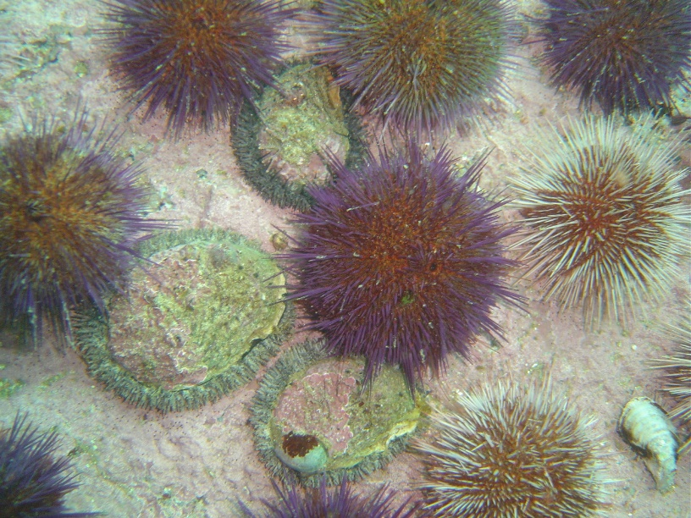For IMTA systems to succeed, both species being co-cultured should have commercial potential. However, the feasibility of the Cape sea urchin as an additional value-added product has not been investigated as yet. This project is exploring the feasibility of the Cape sea urchin, *Parechinus angulosus*, as a new market product for South Africa which has the potential to be co-cultured with South African abalone, *Haliotis midae*, through an IMTA system. Through the improvement of the culturing protocols for this urchin species, further value could be added to the co-culturing of sea urchins and juvenile abalone, increasing the sustainability of the abalone aquaculture industry and potentially, the Cape sea urchin may diversify the South African aquaculture market.

Figure 2: Image of juvenile abalone (*Haliotis midae*) sheltering beneath Cape sea urchins (*Parechinus angulosus*) in Simon’s Town, Cape Town, South Africa (Peter Southwood, 2005).

## Research aim and objectives

One of the major factors influencing the marketability of sea urchins is their gonad colour and texture (Shpigel et al., 2005). The effects of different temperatures and feeding regimes on the growth performance, optimal gonad colour and gonadal somatic index (GSI) of this species has not been assessed, this project aims to address these knowledge gaps. The spinal colour variation of the Cape sea urchin may potentially impact their gonad colour and thus, may add commercial interest to the species.

* + 1. **Research Aim**

The aim of the study is to assess the potential of the Cape sea urchin, *Parechinus angulosus*, as an additional value-added product within an IMTA system.

* + 1. **Research Objectives:**
       1. Assess somatic growth and gonad development of the Cape sea urchin held at different temperatures: ambient (at Sea Point DFFE mariculture laboratory on the Cape southwest coast) and warmed to 18°C.
       2. Assess the effects of different diets on somatic growth and gonad development of the Cape sea urchin held at different temperatures: the sea lettuce *Ulva lacinulata* (U), *Ecklonia maxima* kelp (K), 16U formulated feed (F), and a combination of the forementioned diets (U, K, F) rotated on a weekly basis to form a mixed diet (M).
       3. Evaluate gonad quality (colour, texture, firmness), under the above-mentioned temperatures and feeding regimes, to assess the feasibility of gonad enhancement and marketability of the Cape sea urchin.
       4. Assess feed conversion ratio, under the above-mentioned temperatures and feeding regimes, of the Cape sea urchin.
       5. Assess the effects of test colour on gonad colour.

# **Literature review**

Parechinus angulosus

* What is it? Where does it live? What does it eat?
* Does it have value (environmental, social, economic, cultural)? What’s it’s role in the food web?
* How does it’s value compare to other urchin species?
* Does this project relate to any gaps in our knowledge about the species?

Echinoculture

* Sea urchin market analysis/summary
* Areas of controversy or need for improvement
* Does this project relate to any gaps within the industry?

Expectations/Previous work

* Has anyone done anything similar? What did they find?
* What are factors that have affected gonad quality/growth rate/feeding rate for other species?

This project

* Motivation for the factors I am considering & methodology followed:
  + Feeds chosen: is it what they naturally eat? (e.g., *Ecklonia maxima* characterizes the environments usually populated by *P. angulosus*)
  + Temperatures chosen
  + How does my methodology compare with other studies?
* Project hypotheses

# **Materials and methods**

## Ethics statement

Wild *Parechinus angulosus* were collected in the intertidal and shallow subtidal on a rocky shore in front of the DFFE Marine Research Aquarium in Sea Point, Cape Town (33° 55' 6.492'' S, 18° 22' 52.572'' E). This site is not privately owned or protected in any way, according to South African legislation (SAFLII, 2019). This study did not include endangered or protected species. All experimental procedures on animals were in compliance with the welfare guidelines of the DFFE. Daily biosecurity checks were performed for the duration of the study according to the biosecurity standard of the DFFE.

## Sea urchin collection

The sea urchins (*Parechinus angulosus*) were collected from the rock pools in front of the Marine Research Aquarium in Sea Point in May 2023. A total of 650 individuals of an average size of 4cm diameter were collected and immediately transported to plastic tanks with a flow-through system er at the Marine Research Aquarium. Prior to the start of the experiment the urchins were starved for three weeks to reduce their gonad weight and ensure that all animals had a similar gonad state prior to the start of the trial. Thereafter, the urchins were stocked into oyster mesh baskets (L x W x D: 40 x 29 x 16 cm; mesh size: 6 mm) suspended in smaller plastic tanks (L x W x H: 42 x 36 x 30 cm) at 19 animals per basket (stocking density) and fed *Ecklonia maxima* for two weeks while they acclimatised to the experimental system. A similar size range of urchins (state Mean ±SD of TD and/or TW) were stocked in each basket across the various treatments to mitigate against growth rate differences due to different sized animals. *Parechinus angulosus* has a wide range of spinal colours (pink, light purple, dark purple, orange and red), some more rare than others. Where possible, equal ratios of urchins with different test colours were selected for each basket.

## Experimental setup

A flow-through (how many l per hour? Tank turnover per day?) experimental system was utilized for the trials, consisting of 32 rectangular plastic tanks (L x W x H: 42 x 36 x 30 cm). There were four tanks (replicates) for each treatment and each tank had a volume of 40 l; when accounting for the height of the outflow. Seawater for the ambient and the heated tanks was pumped from the kelp beds in front of the DFFE Marine Research Aquarium (MRA). Before entering the experimental systems, seawater passed through a drum filter and then a sand filter prior to entering a sump tank at the highest level of the MRA. For the ambient system, water from the sump was gravity fed into the experimental tanks at a rate of xyz L/min. Conversely, for the heated system, water from the main sump at the MRA was gravity fed into two interconnected 2,500 L JoJo tanks where the water was constantly recirculated through a heat pump set at 19 oC before entering the experimental tanks, at a rate of xyz L/min. This experimental system included two temperature treatments: ambient (A: ambient) incoming water and a consistent temperature (W: warm) of 18°C (temperature controlled using a heat pump).The exact temperature in the ambient and heated experimental tanks was continuously recorded at 30-minute intervals using a temperature probe (brand/model) and the average temperature over the entire experimental period was 15.36 ±0.009 oC and 18.88 ± 0.006 oC for the ambient and heated systems, respectively.

The aeration in the tanks was provided by one airstone per tank. Effluent water returned directly to the ocean through the main effluent pipe of the MRA. The density of animals and feed we use is so low it has minimal impact on the surrounding environment. You can state this if you wish, but probably not necessary.

The internal surfaces of tanks were manually cleaned of their sediments and fouling organisms twice a week, using a siphon and synthetic fibre brush.

Four feeding regimes were tested in quadruplicate: *Ulva* (U), kelp (K), a formulated feed containing 20% *Ulva* (F), as well as a combination of the forementioned diets (U, K, F) rotated on a weekly basis to form a mixed diet (M), resulting in a total of 16 tanks (320 sea urchins). All feeds will be administered ad libitum, to avoid overfeeding, the amount of feed added at the start of the experiment was calculated as a percentage of the total body weight within each tank (U: 8%, F: 1.8%, K: 10%).

Therefore, a total of 32 tanks were stocked with sea urchins, equating to 640 sea urchins for inclusion in the study.

The 8 treatments were randomly assigned to tanks in the following arrangement:

Table 1. Tank treatment allocation

(F: formulated feed, M: mixed diet, U: ulva, K: kelp, A: ambient, W: warm).

|  |  |  |  |
| --- | --- | --- | --- |
| FW 1 | MW 2 | FA 3 | MA 4 |
| MW 5 | UW 6 | KA 7 | UA 8 |
| UW 9 | KW 10 | KA 11 | FA 12 |
| FW 13 | MW 14 | UA 15 | MA 16 |
| UW 17 | KW 18 | FA 19 | KA 20 |
| KW 21 | UW 22 | MA 23 | FA 24 |
| MW 25 | FW 26 | UA 27 | UA 28 |
| KW 29 | FW 30 | MA 31 | KA 32 |

## Data collection

### *Somatic growth and feed conversion ratio*

Somatic growth was measured in terms of urchin total wet weight (g) and diameter (cm) at six measurement timepoints (T0: initial, T1: 4 weeks, T2: 8 weeks, T3: 13 weeks, T4: 18 weeks, T5: 23 weeks)- over the course of the study. At every timepoint all sea urchins were individually weighed and measured using standardised photographs taken with an iPhone 8. All images were processed using the “Urchin Vision” software developed by De Vos et al. (2023) and the average diameters and weights of animals in each tank were recorded.

Feed conversion ratios were measured for each tank by determining feed consumption over a 7 day period, divided by the corresponding wet weight increase over the 7 days using the following formulae:

All urchins were weighed at the start of the week (for week 0, 4, 8, 13, 18 and 23), these values were used for the somatic growth data. To allow the sea urchins to adapt to the treatments before feed consumption was measured, feed consumption measurements were recorded from week 8 onwards.

All urchins were measured again at the end of the week (for weeks 8, 13, 18 and 23), these values were used to calculate wet weight increase over the 7 days. The total feed consumed per tank over the 7 days was calculated as the difference between the feed introduced and the residual feed removed from the tank. The amount of feed added to the tank was weighed, in grams, at the start of the week.

Macroalgae tissues (Ulva and Ecklonia maxima) were still intact after 7 days when residual material was removed and therefore, no significant process of degradation and weight reduction within the experimental time was considered. These tissues were spun using a salad spinner to remove excess moisture before they were weighed. The formulated feed however, was significantly degraded, and the residual formulated feed in each tank was thus removed every 3 days and new formulated feed was weighed (g) and added for the experiment. The residual formulated feed was placed into foil weigh boats and dried to a constant weight in an oven at 60oC for 48 hours to remove excess moisture before being weighed. Feed consumption was calculated in milligrams of feed (dry weight) consumed per tank, per week. The feed consumption was then divided by the number of animals in the tank and by the number of days for the feed consumption experiment to calculate the average feed (dry weight in milligrams) consumed per animal, per day.

### *Gonad quality and development*

Gonad quality was measured in terms of gonadal somatic index (GSI) (%) and gonad colour approximately every two months (T0GSI: 9 weeks, T1GSI: 19 weeks, T2GSI: 26 weeks). At each sampling point, one urchin from each tank was weighed, sacrificed, and dissected. The gonads were carefully removed from the test and all other visceral tissues attached to the gonad were cleaned off, before determining total gonad weight (g) for each animal for the evaluation of GSI using the following formulae:

Gonad colour was measured using a hand-held fibre-optic spectrophotometer (Lovibond® LC 100 spectrocolorimeter). For the spectrophotometer rated gonad colour, three replicate measurements of L* (intensity or lightness), a* (hue or redness) and b* (chroma or yellowness) were taken from each sampled gonad (Onomu et al., 2020).

Gonad development was measured by the gametogenic state of the urchin. A single gonad per animal, of the five extracted for the GSI measurements, was fixed in Davidson's fixative for histological analysis to ascertain the gametogenic state of the urchin. After 48 hr of immersion in the fixative, the samples were transferred to 70% ethanol for storage prior to paraffin histology (Bucke, 1989). Gonad maturity was analysed according to the method described by Cyrus, Bolton, and Macey (2015). Gonads were categorized into one of 6 different maturity stages of echinoid gametogenesis, namely (a) recovery, (b) growing, (c) premature, (d) mature, (e) partly spawned, and (f) spent (Vaïtilingon, Rasolofonirina, & Jangoux, 2005). Gonads having little or no gametogenic activity were considered as high-quality, that is gonads in the growing or premature stages (Onomu et al., 2020).

## Statistical Analyses

To determine whether urchin SGR (in terms of weight and size), mortality, GSI and gonad colour (L*, a* and b*) changed as a function of time within individual treatment groups or as a function of treatment at individual sampling dates, a one-way analysis of variance (ANOVA) was performed using R statistical software (R Core Team, 2023).

The somatic growth data collected in terms of weight (g) (Table no) and size (cm diameter) (Table no) was averaged per tank and used to calculate the specific growth rate (SGR). SGR (% growth/day) (Table no) of each treatment was calculated for five intervals (between each respective timepoint) using mean weight (g) and size (mm) measurements per timepoint per tank per treatment:

Where mf = measurement final (g or cm); mi = measurement initial (g or cm); t = time (days) between final and initial measurements.

The intervals for the five specific growth rates calculated:

1. A: week 0 - week 4 (t = 29 days)
2. B: week 4 – week 8 (t = 29 days)
3. C: week 8 – week 13 (t = 32 days)
4. D: week 13 – week 18 (t = 36 days)
5. E: week 18 – week 23 (t = 36 days)

Normality & Homoscedasticity

Normality was assessed using the Shapiro-Wilk test (Shapiro & Wilk, 1965). Homoscedasticity was assessed using a Levene’s test (Schultz, 1985) in the “car” package (Fox & Weisberg, 2019) to compare the variances of the treatment groups.

*Weight*

First, I did Shapiro-Wilk tests on the SGR of all tanks for a given time interval e.g., Shapiro-wilk(tank_SGR_data$SGR1): SGR A, B and D were normal (p = 0.69, p = 0.07, p = 0.35). SGR C was not normal (p = 0.02).

Levene test compares SGR by treatment. (If values are significant, the treatment group data does not have equal variances). SGR A (df = 7 , F= 1.127 p = 0.3792) and D (df = 7, F = 1.7097, p = 0.1542) have equal variances. SGR B (p = 0.03) and C (p = 0.004) do not have equal variances.

* Normal: A,B,D
* Equal variance: A,D
* ANOVA: A,D – results below
* Correct unequal variances: B,C?
* Kruskal Wallis for C?

*Size*

* Only SGR B is normal
* Variances all equal
* So Kruskal Wallis for all except SGR B?

*I haven’t managed to get through the analysis for these yet, want to first make sure I’m on the right track with somatic growth:*

*Survival rate*

*Feeding rate*

*FCR*

*GSI*

*Gonad colour*

# **Results**

## Survival

The survival rates per tank were not normally distributed (W = 0.86, p < 2.2e-16) but the variances were equal (F = 1.42, p = 0.19). The results of the Kruskal-Wallis rank sum test showed that survival rate did not differ significantly between temperatures (χ2 = 0.006, df = 1, p = 0.94) but there were significant differences between diets (χ2 = 72.565, df = 3, p = 1.205e-15).

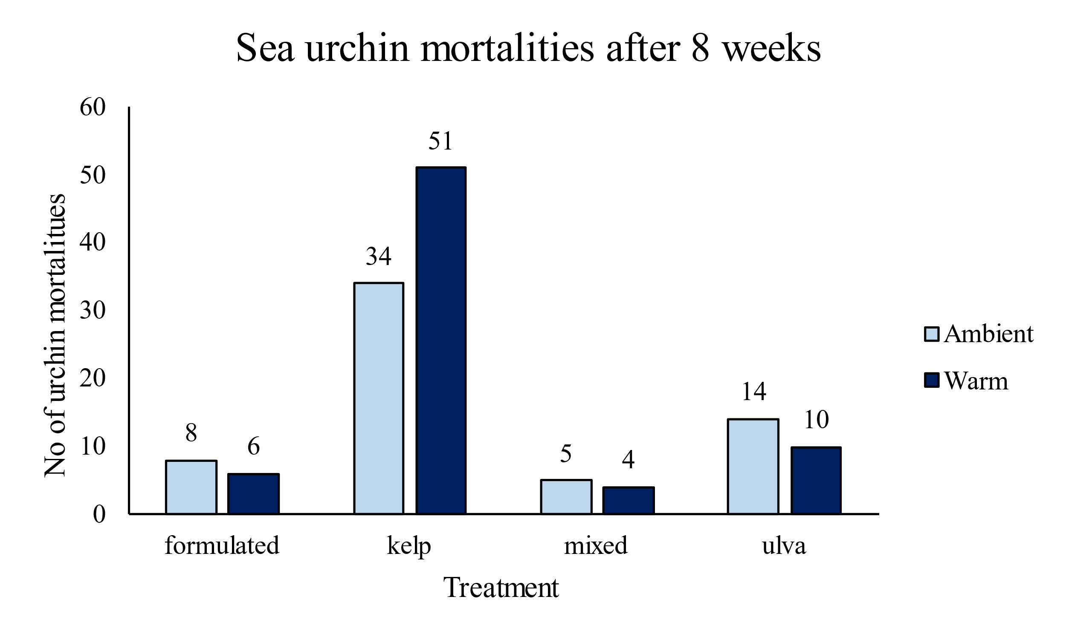

## Somatic growth

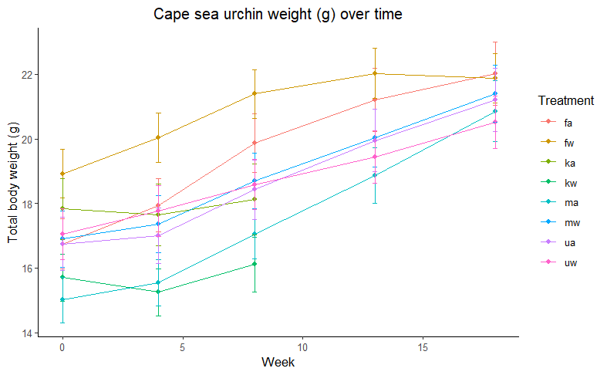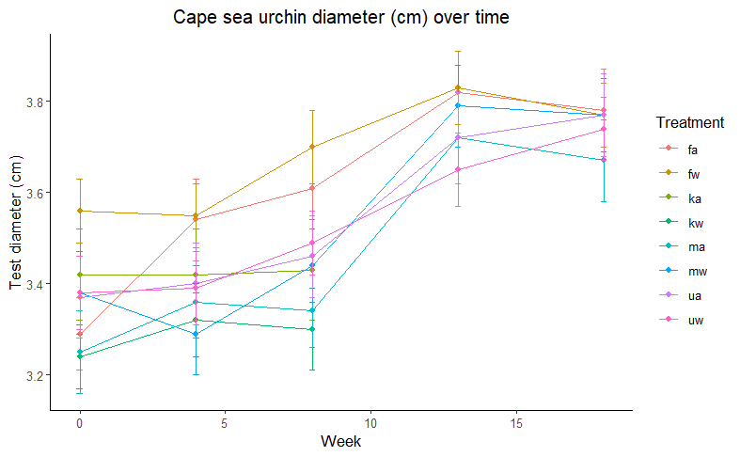

**b)**

**a)**

Figure 3: a) Cape sea urchin mean weight (g) and b) size in terms of diameter (cm) with standard error as error bars over time for the 8 different treatments (f: formulated, m: mixed, u: ulva, k: kelp, w: warm tanks, a: ambient tanks)

*Weight*

*Period A*

The SGR for period A (week 0 – week 4) was significantly different between treatments (df = 7, F = 18.32, p = 3.34e-08). The diet treatment factor strongly influenced these differences (df = 3, F = 39.201, p = 2.08e-09) while temperature did not (df = 1, F = 0.523, p = 0.48). The highest SGR (% growth/day) for period A was from the formulated diet (mean ± se) (0.22 ± 0.02 % growth/day) and the kelp diet the lowest SGR (-0.07 ±0.03 %growth/day). All diets had significantly different SGR’s in period A (Post Hoc Tukey) except for the mixed and ulva diets (p = 0.967).

*Period D*

The SGR for period D (week 13 – week 18) was significantly different between treatments (df = 7, F = 9.96, p = 0.000423). The diet treatment factor strongly influenced these differences (df = 3, F = 11.64, p = 4.48e-05) while temperature did not (df = 1, F = 3.59 , p = 0.07). The highest SGR (% growth/day) for period D was from the mixed diet (mean ± se) (0.23 ± 0.03 % growth/day) and the formulated diet the lowest SGR (0.04±0.05 %growth/day). Only the mixed and formulated diets had significantly different SGR’s in period D (Post Hoc Tukey) (p = 0.002).Ulva had an SGR of 0.16 ± 0.03 % growth/day.

# **Discussion**

# **Conclusion**

# **References**

Britz P. J., Hecht T., Mangold S., 1997 Effect of temperature on growth, feed consumption and nutritional indices of *Haliotis midae* fed a formulated diet. Aquaculture 152: 191–203.

Britz P.,Venter S., 2016. Aquaculture Review: South Africa. World Aquaculture: 20-28.

Bucke D., 1989. Histology. In B. Austin & D. A. Austin (Eds.), Methods for the microbiological examination of fish and shellfish (pp. 69–97). Chichester: Ellis Horwood.

Day E., Branch G. M., 2000 Relationships between recruits of abalone *Haliotis midae*, encrusting corallines and the sea urchin *Parechinus angulosus*. South African Journal of Marine Science: 137–144.

Day E., Branch G. M., 2002a Influences of the sea urchin *Parechinus angulosus* (Leske) on the feeding behaviour and activity rhythms of juveniles of the South African abalone *Haliotis midae* Linn. Journal of Experimental Marine Biology and Ecology 276: 1–17.

Day E., Branch G. M., 2002b. Effects of sea urchins (*Parechinus angulosus*) on recruits and juveniles of abalone (*Haliotis midae*). Ecological Monographs 72: 133–149.

De Vos B. C., Cyrus M. D., Macey B. M., Batik T., Bolton J. J., 2023. Combining computer vision and standardised protocols for improved measurement of live sea urchins for research and industry. Aquaculture, Fish and Fisheries. <https://doi.org/10.1002/aff2.137>

FAO, 2022. The State of World Fisheries and Aquaculture 2022. Towards Blue Transformation. Rome, FAO. <https://doi.org/10.4060/cc0461en>

Fox J., Weisberg S. 2019. An R Companion to Applied Regression. Third edition. Sage, Thousand Oaks CA. <https://socialsciences.mcmaster.ca/jfox/Books/Companion/>

Fricke A. H., 1980. Aspects of Population Structure of *Parechinus Angulosus* (Leske), Around the Cape Peninsula. South African Journal of Zoology 15: 177–185.

Granada L., Sousa N., Lopes S., Lemos M. F. L., 2016 Is integrated multitrophic aquaculture the solution to the sectors’ major challenges? – a review. Reviews in Aquaculture 8: 283–300.

Kang K. H., Kwon J. Y., Kim Y. M., 2003 A beneficial co-culture : charm abalone *Haliotis discus hannai* and sea cucumber *Stichopus japonicus*. Aquaculture 216: 87–93.

Kim T., Yoon H.S., Shin S., Oh M.H., Kwon I., Lee J., Choi S. D., Jeong K. S., 2015 Physical and biological evaluation of co-culture cage systems for grow-out of juvenile abalone, *Haliotis discus hannai*, with juvenile sea cucumber, *Apostichopus japonicus* (Selenka), with CFD analysis and indoor seawater tanks. Aquaculture 447: 86–101.

Mayfield S., Branch G. M., Cockcroft A. C., 2000. Relationships among diet, growth rate, and food availability for the South African rock lobster, *Jasus lalandii* (Decapoda, Palinuridea). Crustaceana, pp.815-834.

Nepgen C. S., 1982. Diet of predatory and reef fish in False Bay and possible effects of pelagic purse-seining on their food supply. Fisheries bulletin: Contributions to oceanography and fisheries biology-Republic of South Africa, Dept. of Agriculture and Fisheries.

Onomu A. J., Vine N. G., Cyrus M. D., Macey B. M., Bolton J. J., 2020. The effect of fresh seaweed and a formulated diet supplemented with seaweed on the growth and gonad quality of the collector sea urchin *Tripneustes gratilla*, under farm conditions, Aquaculture Research, 51(10): 4087–4102. <https://doi.org/10.1111/are.14752>

R Core Team. 2023. R: A Language and Environment for Statistical Computing. R Foundation for Statistical Computing, Vienna, Austria. <https://www.R-project.org/> .

South African Legal Information Institute (SAFLII). 2019. South Africa: Consolidated Regulations - Declaration of Areas as Marine Protected Areas. Available at: <https://www.saflii.org/za/legis/consol_reg/doaampa357/> (Accessed: 16 November 2023).

Shpigel, M., McBride, S. C., Marciano, S., Ron, S. and Ben-Amotz, A., 2005. Improving gonad colour and somatic index in the European sea urchin *Paracentrotus lividus*. Aquaculture, 245(1-4), pp.101-109.

Smith, C. D., 1999. Population biology and ecology of octopuses in the Southwestern Cape: a study towards the establishment of a small-scale octopus fishery (Master's thesis, University of Cape Town).

# **Appendix**

# Actual Values

***Weight***

Table 8.1.1 Descriptive statistics for weight (g) of all tanks, in terms of mean, standard deviation and variance, of *P. angulosus* urchins at the start of the experiment.

|  |  |  |  |  |  |  |
| --- | --- | --- | --- | --- | --- | --- |
| Tank | Diet | Temperature | Mean (g) | St. dev (g) | Var (g^2) | n |
| 1 | formulated | warm | 17.62 | 7.1 | 50.3714 | 19 |
| 2 | mixed | warm | 19.28 | 6.46 | 41.764 | 19 |
| 3 | formulated | ambient | 19.32 | 7.23 | 52.2206 | 19 |
| 4 | mixed | ambient | 14.68 | 6 | 35.9936 | 19 |
| 5 | mixed | warm | 17.06 | 6.78 | 45.9281 | 19 |
| 6 | ulva | warm | 17.11 | 5.47 | 29.9299 | 19 |
| 7 | kelp | ambient | 13.89 | 7.97 | 63.5988 | 19 |
| 8 | ulva | ambient | 18.26 | 6.94 | 48.1692 | 19 |
| 9 | ulva | warm | 16.43 | 7.82 | 61.1243 | 19 |
| 10 | kelp | warm | 14.72 | 5.69 | 32.3618 | 19 |
| 11 | kelp | ambient | 18.29 | 6.91 | 47.7743 | 19 |
| 12 | formulated | ambient | 14.97 | 6.4 | 40.942 | 19 |
| 13 | formulated | warm | 22.19 | 6.73 | 45.261 | 19 |
| 14 | mixed | warm | 14.99 | 8.62 | 74.2894 | 19 |
| 15 | ulva | ambient | 13.71 | 8.17 | 66.7072 | 19 |
| 16 | mixed | ambient | 13.64 | 6.63 | 43.9515 | 19 |
| 17 | ulva | warm | 15.85 | 5.82 | 33.8737 | 19 |
| 18 | kelp | warm | 14.75 | 6.88 | 47.3026 | 19 |
| 19 | formulated | ambient | 16.08 | 7.08 | 50.1406 | 19 |
| 20 | kelp | ambient | 19.73 | 9.23 | 85.2745 | 19 |
| 21 | kelp | warm | 17.16 | 5.63 | 31.6559 | 19 |
| 22 | ulva | warm | 18.78 | 8.29 | 68.7347 | 19 |
| 23 | mixed | ambient | 16.76 | 6.5 | 42.2491 | 19 |
| 24 | formulated | ambient | 16.62 | 5.84 | 34.0618 | 19 |
| 25 | mixed | warm | 16.28 | 8.16 | 66.5295 | 19 |
| 26 | formulated | warm | 17.44 | 5.79 | 33.4891 | 19 |
| 27 | ulva | ambient | 17.21 | 5.18 | 26.8821 | 19 |
| 28 | ulva | ambient | 17.83 | 7.92 | 62.7489 | 19 |
| 29 | kelp | warm | 16.18 | 6.89 | 47.5251 | 19 |
| 30 | formulated | warm | 18.45 | 5.87 | 34.5115 | 19 |
| 31 | mixed | ambient | 14.94 | 5.2 | 27.0348 | 19 |
| 32 | kelp | ambient | 19.39 | 8.27 | 68.4083 | 19 |

Table 8.1.2. Descriptive statistics for weight (g) of all tanks, in terms of mean, standard deviation and variance, of *P. angulosus* urchins at the after 4 weeks.

|  |  |  |  |  |  |  |
| --- | --- | --- | --- | --- | --- | --- |
| Tank | Diet | Temperature | Mean (g) | St. dev (g) | Var (g^2) | n |
| 1 | formulated | warm | 18.88 | 7.26 | 52.6949 | 19 |
| 2 | mixed | warm | 19.5 | 6.96 | 48.4683 | 19 |
| 3 | formulated | ambient | 20.43 | 7.5 | 56.3237 | 19 |
| 4 | mixed | ambient | 15.05 | 5.92 | 35.0205 | 19 |
| 5 | mixed | warm | 17.64 | 6.53 | 42.6362 | 19 |
| 6 | ulva | warm | 18.05 | 5.63 | 31.7518 | 19 |
| 7 | kelp | ambient | 13.98 | 8.12 | 65.911 | 19 |
| 8 | ulva | ambient | 18.62 | 6.96 | 48.4766 | 19 |
| 9 | ulva | warm | 16.79 | 7.98 | 63.7253 | 19 |
| 10 | kelp | warm | 14.15 | 5.54 | 30.7244 | 19 |
| 11 | kelp | ambient | 17.86 | 7.08 | 50.1473 | 19 |
| 12 | formulated | ambient | 16.41 | 7.1 | 50.4783 | 19 |
| 13 | formulated | warm | 23.14 | 6.72 | 45.1203 | 19 |
| 14 | mixed | warm | 15.48 | 8.61 | 74.198 | 19 |
| 15 | ulva | ambient | 13.9 | 8.31 | 69.116 | 19 |
| 16 | mixed | ambient | 14.25 | 6.93 | 48.0077 | 19 |
| 17 | ulva | warm | 16.39 | 5.8 | 33.6618 | 19 |
| 18 | kelp | warm | 13.93 | 6.96 | 48.4531 | 20 |
| 19 | formulated | ambient | 17.24 | 7.83 | 61.3526 | 19 |
| 20 | kelp | ambient | 19.75 | 8.99 | 80.7613 | 19 |
| 21 | kelp | warm | 17.13 | 5.71 | 32.6232 | 19 |
| 22 | ulva | warm | 19.86 | 7.76 | 60.258 | 19 |
| 23 | mixed | ambient | 17.08 | 6.89 | 47.4139 | 19 |
| 24 | formulated | ambient | 17.67 | 6.16 | 37.928 | 19 |
| 25 | mixed | warm | 16.83 | 8.27 | 68.32 | 19 |
| 26 | formulated | warm | 18.66 | 6.01 | 36.1585 | 19 |
| 27 | ulva | ambient | 17.24 | 6.33 | 40.0348 | 19 |
| 28 | ulva | ambient | 18.26 | 8.04 | 64.5841 | 19 |
| 29 | kelp | warm | 15.85 | 7.04 | 49.5105 | 19 |
| 30 | formulated | warm | 19.49 | 6.28 | 39.4706 | 19 |
| 31 | mixed | ambient | 15.8 | 5.51 | 30.398 | 19 |
| 32 | kelp | ambient | 19.02 | 8.21 | 67.4632 | 19 |

Table 8.1.3. Descriptive statistics for weight (g) of all tanks, in terms of mean, standard deviation and variance, of *P. angulosus* urchins at the after 8 weeks.

|  |  |  |  |  |  |  |
| --- | --- | --- | --- | --- | --- | --- |
| Tank | Diet | Temperature | Mean (g) | St. dev (g) | Var (g^2) | n |
| 1 | formulated | warm | 19.99 | 7.41 | 54.867 | 19 |
| 2 | mixed | warm | 20.47 | 6.89 | 47.4198 | 19 |
| 3 | formulated | ambient | 22.72 | 8.32 | 69.2303 | 16 |
| 4 | mixed | ambient | 16.59 | 6.01 | 36.1658 | 19 |
| 5 | mixed | warm | 18.87 | 6.23 | 38.8186 | 19 |
| 6 | ulva | warm | 19.3 | 5.38 | 28.9925 | 19 |
| 7 | kelp | ambient | 13.88 | 8.18 | 66.8324 | 19 |
| 8 | ulva | ambient | 19.68 | 7.56 | 57.108 | 16 |
| 9 | ulva | warm | 17.37 | 7.87 | 61.9862 | 19 |
| 10 | kelp | warm | 14.94 | 5.36 | 28.6934 | 12 |
| 11 | kelp | ambient | 17.97 | 7.99 | 63.7908 | 12 |
| 12 | formulated | ambient | 18.27 | 7.11 | 50.615 | 19 |
| 13 | formulated | warm | 23.97 | 6.55 | 42.952 | 19 |
| 14 | mixed | warm | 16.86 | 8.62 | 74.3562 | 19 |
| 15 | ulva | ambient | 15.18 | 8.18 | 66.9169 | 16 |
| 16 | mixed | ambient | 15.97 | 7.14 | 51.034 | 17 |
| 17 | ulva | warm | 17.15 | 5.56 | 30.9516 | 19 |
| 18 | kelp | warm | 15.25 | 7.71 | 59.4627 | 15 |
| 19 | formulated | ambient | 19.17 | 8.13 | 66.1694 | 18 |
| 20 | kelp | ambient | 21.57 | 8.6 | 73.9394 | 14 |
| 21 | kelp | warm | 16.74 | 5.79 | 33.4755 | 19 |
| 22 | ulva | warm | 20.67 | 7.63 | 58.2224 | 18 |
| 23 | mixed | ambient | 18.5 | 7.34 | 53.8874 | 19 |
| 24 | formulated | ambient | 19.75 | 6.7 | 44.8302 | 17 |
| 25 | mixed | warm | 18.6 | 8.52 | 72.6662 | 19 |
| 26 | formulated | warm | 20.1 | 6.08 | 36.9106 | 19 |
| 27 | ulva | ambient | 19.51 | 5.45 | 29.7481 | 16 |
| 28 | ulva | ambient | 19.21 | 8.21 | 67.4352 | 19 |
| 29 | kelp | warm | 17.25 | 7.4 | 54.8009 | 13 |
| 30 | formulated | warm | 21.51 | 5.87 | 34.4628 | 18 |
| 31 | mixed | ambient | 17.04 | 5.8 | 33.5914 | 19 |
| 32 | kelp | ambient | 20.79 | 6.49 | 42.1843 | 13 |

Table 8.1.4. Descriptive statistics for weight (g) of all tanks, in terms of mean, standard deviation and variance, of *P. angulosus* urchins at the after 13 weeks.

|  |  |  |  |  |  |  |
| --- | --- | --- | --- | --- | --- | --- |
| Tank | Diet | Temperature | Mean (g) | St. dev (g) | Var (g^2) | n |
| 1 | formulated | warm | 20.31 | 7.27 | 52.9097 | 18 |
| 2 | mixed | warm | 21.58 | 6.96 | 48.4486 | 17 |
| 3 | formulated | ambient | 24.17 | 8.44 | 71.2403 | 15 |
| 4 | mixed | ambient | 18.63 | 6.13 | 37.5615 | 18 |
| 5 | mixed | warm | 20.74 | 6.27 | 39.3043 | 18 |
| 6 | ulva | warm | 20.25 | 5.78 | 33.3526 | 17 |
| 8 | ulva | ambient | 21.21 | 7.65 | 58.5474 | 14 |
| 9 | ulva | warm | 18.46 | 7.79 | 60.7417 | 19 |
| 12 | formulated | ambient | 19.56 | 7.34 | 53.9176 | 18 |
| 13 | formulated | warm | 24.29 | 6.43 | 41.294 | 18 |
| 14 | mixed | warm | 17.9 | 8.29 | 68.7212 | 18 |
| 15 | ulva | ambient | 16.74 | 8.14 | 66.1864 | 14 |
| 16 | mixed | ambient | 17.36 | 8.09 | 65.4172 | 13 |
| 17 | ulva | warm | 17.93 | 5.47 | 29.9158 | 18 |
| 19 | formulated | ambient | 20.66 | 8.6 | 73.9368 | 16 |
| 22 | ulva | warm | 21.31 | 7.76 | 60.2145 | 17 |
| 23 | mixed | ambient | 20.53 | 8.22 | 67.5477 | 18 |
| 24 | formulated | ambient | 20.85 | 6.96 | 48.4965 | 15 |
| 25 | mixed | warm | 19.97 | 8.66 | 74.9715 | 18 |
| 26 | formulated | warm | 20.94 | 6.09 | 37.0816 | 18 |
| 27 | ulva | ambient | 21.41 | 5.01 | 25.057 | 13 |
| 28 | ulva | ambient | 20.38 | 8.14 | 66.33 | 19 |
| 30 | formulated | warm | 22.6 | 5.99 | 35.8858 | 17 |
| 31 | mixed | ambient | 18.51 | 6.18 | 38.24 | 18 |

Table 8.1.5. Descriptive statistics for weight (g) of all tanks, in terms of mean, standard deviation and variance, of *P. angulosus* urchins at the after 18 weeks.

|  |  |  |  |  |  |  |
| --- | --- | --- | --- | --- | --- | --- |
| Tank | Diet | Temperature | Mean (g) | St. dev (g) | Var (g^2) | n |
| 1 | formulated | warm | 20.86 | 7.17 | 51.3513 | 18 |
| 2 | mixed | warm | 22.55 | 6.89 | 47.4575 | 16 |
| 3 | formulated | ambient | 23.53 | 8.24 | 67.8439 | 15 |
| 4 | mixed | ambient | 21.52 | 7.5 | 56.2624 | 18 |
| 5 | mixed | warm | 22.25 | 5.98 | 35.7588 | 18 |
| 6 | ulva | warm | 22.37 | 6.82 | 46.5223 | 17 |
| 8 | ulva | ambient | 22.42 | 7.84 | 61.4795 | 13 |
| 9 | ulva | warm | 19.07 | 7.61 | 57.8832 | 19 |
| 12 | formulated | ambient | 20.38 | 7.11 | 50.5622 | 18 |
| 13 | formulated | warm | 24.49 | 6.32 | 39.9653 | 18 |
| 14 | mixed | warm | 19.62 | 8.2 | 67.1733 | 18 |
| 15 | ulva | ambient | 18.51 | 7.76 | 60.2014 | 12 |
| 16 | mixed | ambient | 18.81 | 8.37 | 70.0828 | 12 |
| 17 | ulva | warm | 19.23 | 5.2 | 27.0423 | 18 |
| 19 | formulated | ambient | 22.6 | 8.48 | 71.8704 | 13 |
| 22 | ulva | warm | 21.73 | 7.43 | 55.1716 | 16 |
| 23 | mixed | ambient | 22.94 | 7.92 | 62.655 | 17 |
| 24 | formulated | ambient | 21.98 | 7.4 | 54.727 | 15 |
| 25 | mixed | warm | 21.31 | 8.42 | 70.9714 | 18 |
| 26 | formulated | warm | 19.57 | 5.89 | 34.7206 | 18 |
| 27 | ulva | ambient | 22.35 | 5.44 | 29.6476 | 13 |
| 28 | ulva | ambient | 21.3 | 8 | 63.9325 | 18 |
| 30 | formulated | warm | 22.64 | 5.74 | 32.9467 | 17 |
| 31 | mixed | ambient | 19.62 | 6.86 | 47.1272 | 18 |

# SGR Values

Table 8.2.1. SGR’s (%growth/day) of all tanks

(A: week 0 – week 4, B: week 4 0 week 8, C: week 8 – week 13, D: week 13 – week 18)

|  |  |  |  |  |  |  |  |
| --- | --- | --- | --- | --- | --- | --- | --- |
| Tank | Diet | Temperature | Treatment | SGR_A | SGR_B | SGR_C | SGR_D |
| 1 | formulated | warm | fw | 0.24 | 0.2 | 0.05 | 0.07 |
| 2 | mixed | warm | mw | 0.04 | 0.17 | 0.17 | 0.12 |
| 3 | formulated | ambient | fa | 0.19 | 0.37 | 0.19 | -0.07 |
| 4 | mixed | ambient | ma | 0.09 | 0.34 | 0.36 | 0.4 |
| 5 | mixed | warm | mw | 0.12 | 0.23 | 0.3 | 0.2 |
| 6 | ulva | warm | uw | 0.18 | 0.23 | 0.15 | 0.28 |
| 7 | kelp | ambient | ka | 0.02 | -0.02 | 0 | 0 |
| 8 | ulva | ambient | ua | 0.07 | 0.19 | 0.23 | 0.15 |
| 9 | ulva | warm | uw | 0.07 | 0.12 | 0.19 | 0.09 |
| 10 | kelp | warm | kw | -0.14 | 0.19 | 0 | 0 |
| 11 | kelp | ambient | ka | -0.08 | 0.02 | 0 | 0 |
| 12 | formulated | ambient | fa | 0.32 | 0.37 | 0.21 | 0.11 |
| 13 | formulated | warm | fw | 0.14 | 0.12 | 0.04 | 0.02 |
| 14 | mixed | warm | mw | 0.11 | 0.29 | 0.19 | 0.25 |
| 15 | ulva | ambient | ua | 0.05 | 0.3 | 0.31 | 0.28 |
| 16 | mixed | ambient | ma | 0.15 | 0.39 | 0.26 | 0.22 |
| 17 | ulva | warm | uw | 0.12 | 0.16 | 0.14 | 0.19 |
| 18 | kelp | warm | kw | -0.2 | 0.31 | 0 | 0 |
| 19 | formulated | ambient | fa | 0.24 | 0.37 | 0.23 | 0.25 |
| 20 | kelp | ambient | ka | 0 | 0.3 | 0 | 0 |
| 21 | kelp | warm | kw | -0.01 | -0.08 | 0 | 0 |
| 22 | ulva | warm | uw | 0.19 | 0.14 | 0.1 | 0.05 |
| 23 | mixed | ambient | ma | 0.07 | 0.28 | 0.33 | 0.31 |
| 24 | formulated | ambient | fa | 0.21 | 0.38 | 0.17 | 0.15 |
| 25 | mixed | warm | mw | 0.11 | 0.34 | 0.22 | 0.18 |
| 26 | formulated | warm | fw | 0.23 | 0.26 | 0.13 | -0.19 |
| 27 | ulva | ambient | ua | 0.01 | 0.43 | 0.29 | 0.12 |
| 28 | ulva | ambient | ua | 0.08 | 0.17 | 0.18 | 0.12 |
| 29 | kelp | warm | kw | -0.07 | 0.29 | 0 | 0 |
| 30 | formulated | warm | fw | 0.19 | 0.34 | 0.15 | 0 |
| 31 | mixed | ambient | ma | 0.19 | 0.26 | 0.26 | 0.16 |
| 32 | kelp | ambient | ka | -0.07 | 0.31 | 0 | 0 |

Table 8.2.1. Results of a two factor ANOVA testing the differences in SGR (%growth/day) of urchins under 4 dietary treatments and 2 temperature treatments between week 0 and week 4. The sources of variation, the values of their sums of squares (Sum Sq), degrees of freedom (Df) and Mean sums of squares (Mean Sq) are shown, together with the resulting F statistic (F value) and probability (Pr(>F)).

|  |  |  |  |  |  |  |
| --- | --- | --- | --- | --- | --- | --- |
|  | Df | Sum Sq |  | Mean Sq | F value | Pr(>F) |
| Diet | 3 | 0.3403 |  | 0.11344 | 31.012 | 6.78e-09 *** |
| Temperature | 1 | 0.0015 |  | 0.00151 | 0.413 | 0.526 |
| Residuals | 27 | 0.0988 |  | 0.00366 |  |  |

Table 8.2.1. Results of a one factor ANOVA testing the differences in SGR (%growth/day) of urchins under 4 dietary treatments between week 0 and week 4. The sources of variation, the values of their sums of squares (Sum Sq), degrees of freedom (Df) and Mean sums of squares (Mean Sq) are shown, together with the resulting F statistic (F value) and probability (Pr(>F)).

|  |  |  |  |  |  |  |
| --- | --- | --- | --- | --- | --- | --- |
|  | Df | Sum Sq |  | Mean Sq | F value | Pr(>F) |
| Diet | 3 | 0.3403 |  | 0.11344 | 31.68 | 3.85e-09 *** |
| Residuals | 28 | 0.1003 |  | 0.00358 |  |  |